

Escuela Particular Las Naciones Nº1973

Avenida Las Naciones 800 Maipú

RBD : 25808-3 Fono: 7712401

[Escuelalasnaciones1973@hotmail.com](mailto:Escuelalasnaciones1973@hotmail.com)

**ENGLISH GUIDE N°2**

**UNIT 3 “Going Places”**

**8TH GRADE**

**Name:** ____________________________________________________**Date: _______________**

|  |
| --- |
| **OA8:**  Demostrar conocimiento y uso del lenguaje identificando contenidos relacionados a la unidad 3.  **Contenidos:**   * Vocabulario (Construcciones y Edificios) |

**Constructions and Buildings:** Construcciones y Edificios

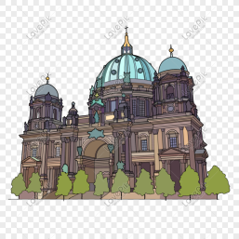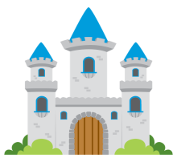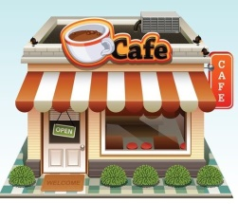

**Cathedral:**

Catedral

**Castle:**

Castillo

**Café:**

Cafetería

**Bookstore:**

Tienda de libros

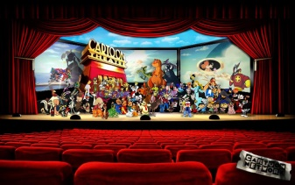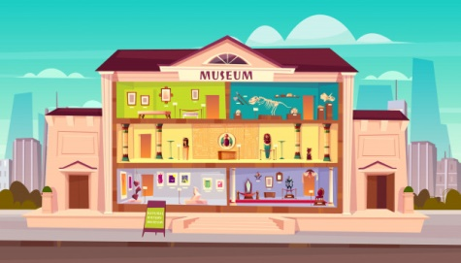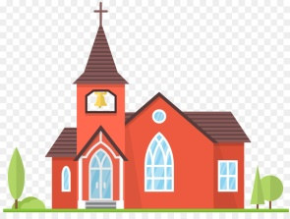

**Theatre:**

Teatro

**Museum:**

Museo

**Department store:**

Multitienda

**Church:**

Iglesia

**Exercises:**

1. Lee cada definición, presente en la columna A, y únelo a la imagen que corresponda, presente en la columna B.

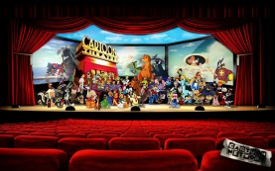 A B

1. It is a place where you can buy books.

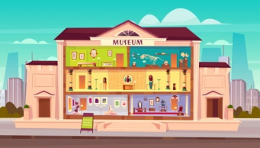

2. It is a place where you can drink a coffee.



3. It is a place where the king and the queen live.

****4. It is a place where a bishop lives.

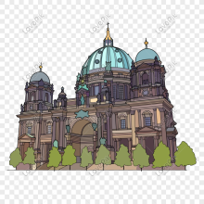5. It is a place where a parrish priest lives.

6. It is a place where you can buy in different stores.



7. It is a place where you can learn about history.

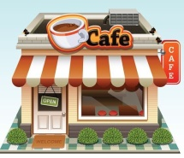8. It is a place where you can watch a play with actors.

